MY LIFE WHEEL (My Life, 5 Years from Today)

STEP 1: MY LIFE WHEEL
The Life Wheel (from sales guru, Zig Ziglar)
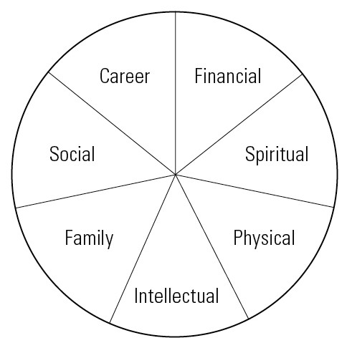
Balance in life is achieved when we are satisfied that we are addressing all areas of the life wheel; if one or more areas of the wheel “go flat,” we feel out of balance.

Rank order the seven areas of the wheel, 1 being the area you are most satisfied with your overall performance/ability/efficacy today, 7 being the area you feel needs the most attention.
1.
2.
3.
4.
5.
6.
7.
STEP 2: DESCRIPTIVE EXPLANATION
For the free-write activity, put #5, 6, and 7 from the life wheel rank order list in the table below, as the areas of your life wheel that you feel need the most attention.

Describe each area as it is now and how you envision it to be in the future, 5 years from today. Be complete, and write both your NOW and VISION in the PRESENT TENSE. Below is an example of one student’s PHYSICAL VISION for the future. She wrote it in present tense to make sure she could envision herself truly being like this:

PHYSICAL VISION: I am very careful about what I eat. I prefer healthy food and I eat balanced meals and snacks and the calorie intake that is proportionate to my desired weight. I drink plenty of liquids to keep me hydrated. I eat my herbs every day to help my body stay in tune and to help maintain my weight at 135 pounds. At this weight I look good in a swimsuit, even a two-piece.

I exercise 4 or more times a week for cardio and strength. Often, I exercise out of doors. I like to exercise alone because it allows me to think. I also like exercising with friends for the social connection and accountability to get out and do it, and I often initiate fun activities with my friends, especially on the weekends. I have maintained my strength and body size for quite some time now. Because of my strength, endurance, and great flexibility, I am not afraid to try most any recreational activity, knowing I will be able to participate at some level.

As you fill in the table, be comprehensive, clear, and realistic but visionary. 100+ words per cell is expected.

LIFE WHEEL AREAS that I want to attend to the most | NOW  Describe this area of your life, as it is today. | VISION  Describe how you would like this area to be 5 years from today.
5.
6.
7.

STEP 3: USE THIS CHECKLIST TO MAKE SURE YOUR VISIONS ARE WELL WRITTEN.

Respond to each question with a detailed explanation.

- Are your goals all visionary? Explain why or why not?

- Are my visions morally right and fair to all involved? Explain why or why not?

- Are all visions consistent with one another? Do they align or interconnect where there is a fit? Explain why or why not?

- Can you emotionally commit yourself to these visions? Explain why or why not?

- Can you see yourself actually reaching or achieving your visions? Explain why or why not?

